**IBM CLOUD SERVICE**

**SONA T**

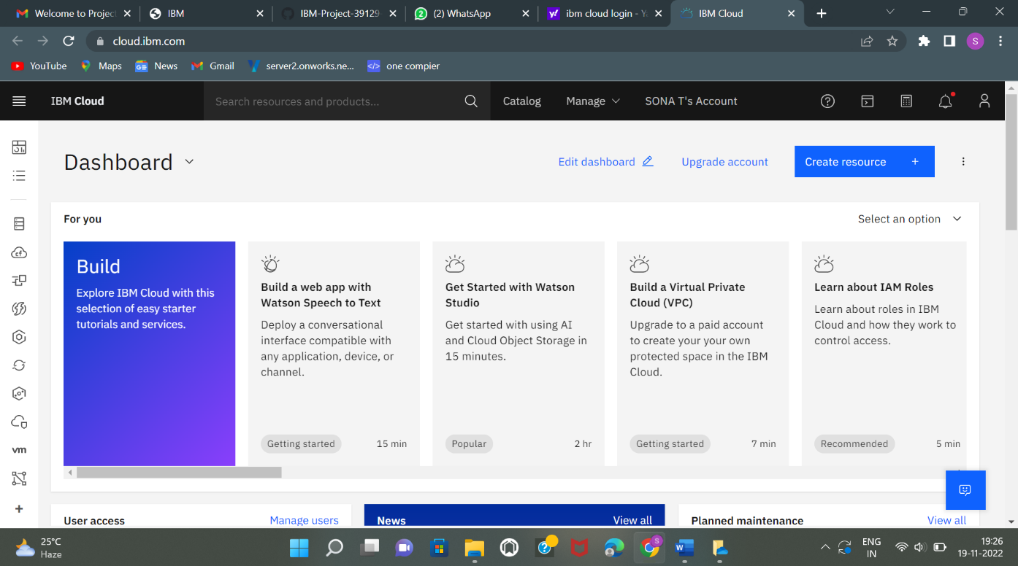

**Srimathi V**

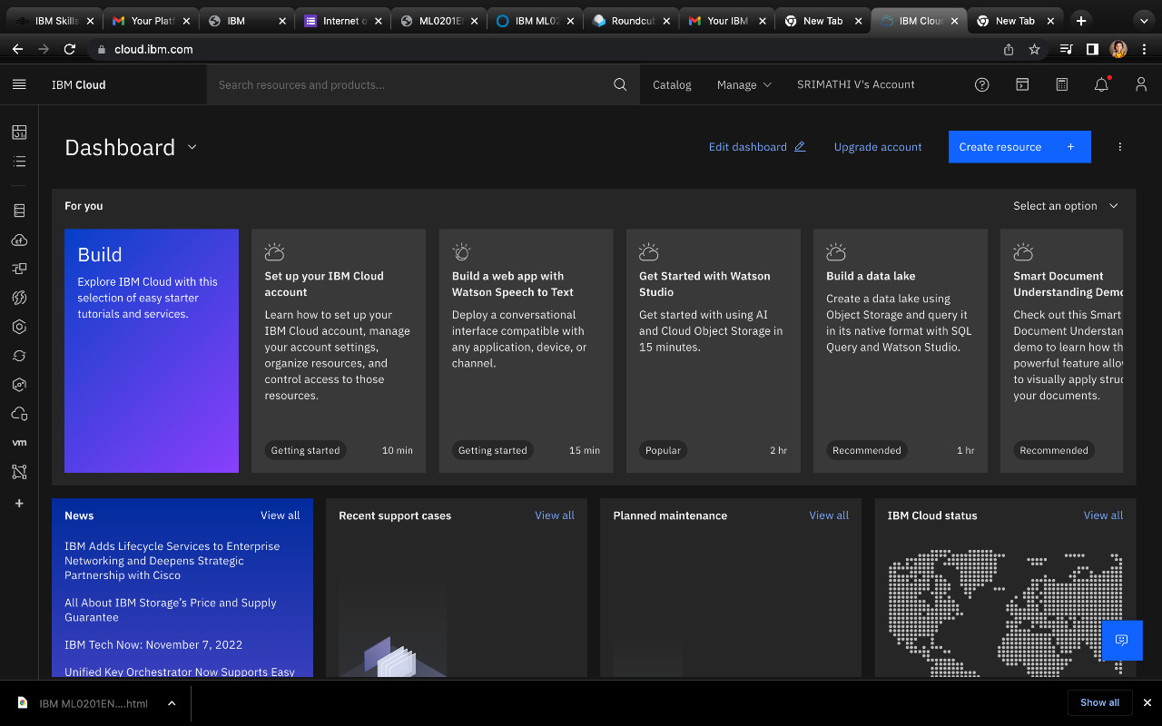

**Rithanya K**

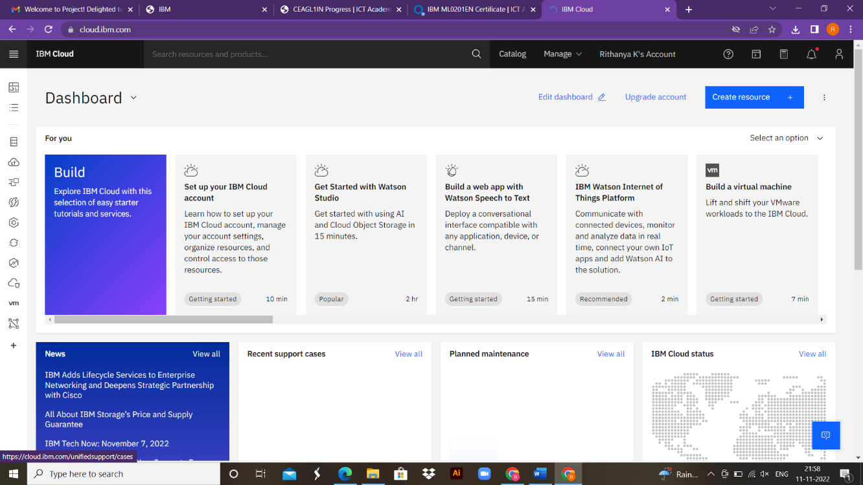

**Venkatesh Manikanda Prabhu**

